**User Guide**

University of Maryland Global Campus

SWEN 670 – Team A

Fall Semester

Version 1.0

November 5, 2022

Document Control

Document Information

|  |  |
| --- | --- |
| © | Information |
| Document Id | MailSpeak User Guide |
| Document Owner | UMGC SWEN 670 TEAM A |
| Issue Date | November 3, 2022 |
| Last Saved Date | November 5, 2022 |
| File Name | UG - Team A (v1.0).docx |

Document History

|  |  |  |
| --- | --- | --- |
| Version | Issue Date | Changes |
| 1.0 | 11/05/2022 | Initial Version |
|  |  |  |
|  |  |  |
|  |  |  |

Table of Contents

1 Introduction 1

1.1 Overview 1

1.2 Project Documents 1

1.3 Acronyms and Abbreviations 2

2 Hardware Requirement 2

3 Software Requirements 2

4 Application Screens 2

4.1 Log-in – Email Credentials 3

4.2 Main Menu 6

4.3 Search Mail 8

4.4 Individual Mail piece View 10

4.5 Daily Digest 11

4.6 Upload Mail 13

4.7 Scan Mail 14

4.8 Settings 15

4.9 Notifications 17

4.10 Chat Support 19

5 Launching the Application 21

5.1 Permissions 21

6 Step-by-step Guide 21

7 FAQ / Troubleshooting 31

7.1 Application is not updating 31

7.2 Application can’t log in to email account 31

7.3 Application is not loading new email 32

7.4 Unable to upload mail image or use camera 33

# Introduction

This user guide describes the functionality and operations of the MailSpeak mobile application developed by the UMGC Fall 2022 SWEN 670 cohort. It is the goal of this document to familiarize the end user with this application to help facilitate its use.

## Overview

MailSpeak is an Android and iOS mobile application that was developed to help people with visual impairment navigate the United Stated Postal Service (USPS) Informed Delivery service by accessing their Informed Delivery email. Informed Delivery is a service that shows preview images of incoming mail and reports the status of incoming/outbound packages daily through a Daily Digest email. The MailSpeak application introduces accessibility for the visually impaired by implementing screen reading capabilities (on all devices) and voice commands (on Android only at this time, with plans to add Apple support in the future). These features along with MailSpeak’s user interface will allow end users to search for mail, view the mail, and follow any links that may be present.

## Project Documents

The following documents are included in the project's software documentation package:

|  |  |  |  |
| --- | --- | --- | --- |
|  | Document | Version | Date |
| 1 | Project Management Plan (PMP) | 1.2 | 9-17-2022 |
| 2 | Software Requirements Specification (SRS) | 1.2 | 10-29-2022 |
| 3 | Technical Design Document (TDD) | 1.2 | 10-29-2022 |
| 4 | Software Test Plan (STP) | 1.1 | 10-29-2022 |
| 5 | Programmers Guide (PG) | 1.1 | 11-05-2022 |
| 6 | Deployment and Operations (DevOps) | 1.1 | 11-05-2022 |
| 7 | User Guide (UG) | 1.0 | 11-05-2022 |
| 8 | Test Report (TR) | 1.0 | 11-05-2022 |

## Acronyms and Abbreviations

DB – Database

GCP – Google Cloud Services Platform

HI – Hardware Interface

iOS – Apple mobile operating system

ML – Machine Learning

OCR – Optical Character Recognition

UI – User Interface

URL – Uniform Resource Locator (website address such as www.usps.com)

# Hardware Requirement

The MailSpeak App was designed to be used on mobile devices only.  The user must have an Android device or an iOS platform device in order to use this app. This application is not compatible with website, web app, iPad or TV.

The application requires access to the internet to function properly, so the user’s device must have network access. Additionally, in order to use the scanning feature of the application, the user’s device must have a camera.

# Software Requirements

The minimum Android operating system (OS) version needed to run the application is Android 5.0 (also known as Lollipop) with application programming interface (API) Level 21. However, Android 12 with API Levels 31 or above is the preferred Android OS version for the application. The minimum iOS version for the application to run is Version 11.0, while the preferred version is Version 15.6.

# Application Screens

The following MailSpeak app includes eight screens that are described in the following section. The screens include the Email Login, Main Menu, Email Search, Search Results, Individual Email View, Daily Digest, Settings, and Chat Support.

## Log-in – Email Credentials

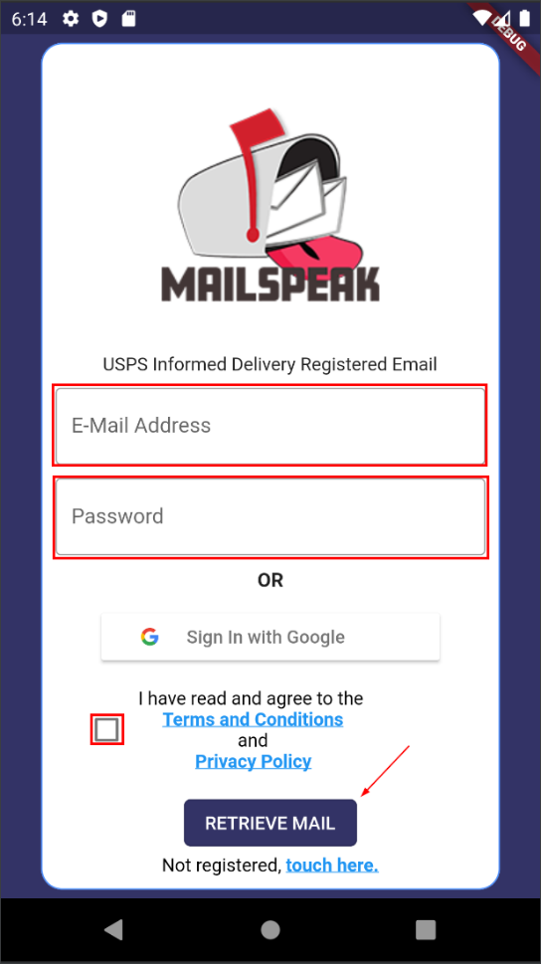

Figure 1 Retrieve Email UI

After users download MailSpeak and launch the application, they will arrive on the Log-in – Email Credentials screen. Assuming they already created an account the user will add their E-Mail Address and Password in the two large red boxes in the picture above. The user will then select the checkmark box stating they have read Terms and Conditions and Privacy Policy. Once the user selects the 'Retrieve Mail’ button, which the arrow is pointing at, the application will log the user into their account and run services to retrieve and process their mail.

### Terms and Conditions

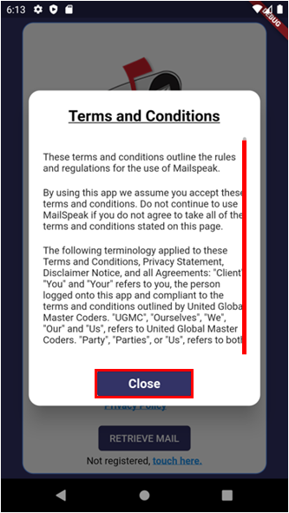

Figure 2 Terms and Conditions Modal

Tapping the Terms and Conditions link from the Email log-in screen provides users with the ability to review MailSpeaks - Terms and Conditions. There is a vertical scrollbar on the right-hand side of the screen and a close button on the button to close the dialog.

### Privacy Policy

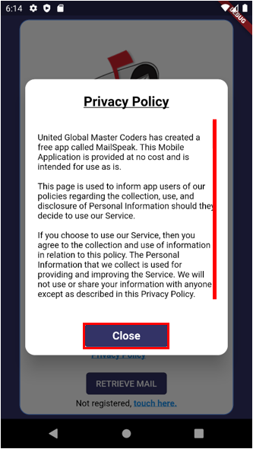

Figure 3 Privacy Policy Modal

Tapping the Privacy Policy link from the Email log-in screen provides users with the ability to review MailSpeaks – Privacy Policy. There is a vertical scrollbar on the right-hand side of the screen and a close button on the button to close the dialog.

## Main Menu

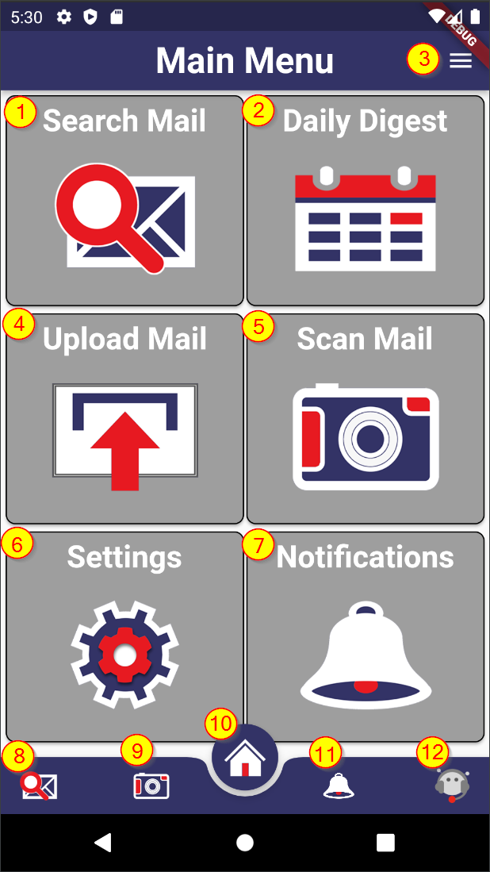

Figure 4 Main Menu UI

The Main Menu is the central launching point for the application.

1. Clicking on ( 1 or 8 ) - Search Mail will allow you to search mail by date, keyword in both sender and mail body text field.
2. Clicking on ( 2 ) - Daily Digest will launch a summary view of all scanned mail of the last day an Informed Delivery message was received.
3. Clicking on ( 3 ) – dropdown on top AppBar menu provides access to settings and logout.
4. Clicking on ( 4 ) – Upload Mail allows users to upload a picture of a piece of mail into the app to leverage the Google Vision OCR and other features of MailSpeak for mail that wasn’t scanned by Informed Delivery.
5. Clicking on ( 5 or 9) – Scan Mail allows users to take a picture of a piece of mail and upload into the app to leverage the Google Vision OCR and other features of MailSpeak for mail that wasn’t scanned by Informed Delivery.
6. Clicking on ( 6 ) – Settings allows the user to review the terms and conditions, privacy policy, and delete all Local Data.
7. Clicking on ( 7 or 11 ) – Notification allows users to add/remove notification keyword subscriptions and view/manage triggered notifications.
8. Clicking on ( 10 ) – Main Menu (Home)
9. Clicking on ( 12 ) – Chatbot allows users to interact with the chatbot through voice or type

### Navigation

There are two navigational elements that are consistent throughout the application, they are the referred to in Flutter as the appBar which is located at the top of the screen and the BottomNavigationBar located at the bottom of the screen. The appBar will contain a back icon capable of navigating the user to the previous screen and a logout icon to allow the user to exit the application. The BottomNavigationBar will contain a set of icons which duplicate the functionality contained on the main menu page as shown below*.*

#### AppBar

Figure 5 AppBar

#### BottomNavigationBar

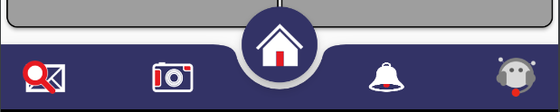

Figure 6 BottomNavigationBar

## Search Mail

### Search Query

Figure 9 Mail Search UI

| **Page: Mail Search** | | | | |
| --- | --- | --- | --- | --- |
| **Purpose:** | |  | |  |
| Provides users with the ability to search through Informed Delivery scanned mail pieces by date ranges and keywords which are used against a variety of text fields captured from a scanned mail piece. | | | | |
| **What to do:** | |  | |
| Select a start and end date for search. Type in a keyword to filter more. Clicking the “Search” button opens the Search Results page.  Clicking the “Search” button without entering any search criteria will return all stored mail pieces.  Entering keyword text will display recommended search results, which can be tapped immediately to go directly to the mail piece view page. | | | | |
| **Content:** |  | |  | |
| **1:** | Calendar | | Assists with visually selecting a start and end date. | |
| **2:** | Start / End Date | | Start and End date for filtering search results. | |
| **3:** | Keyword input | | Option to enter keywords to help filter the results more. Keywords search all mail piece data including sender and image text. | |
| **4:** | Search Button | | Executes the search and opens the search results page. | |
| **5:** | Quick Results | | Displays short list of results based on keystroke input | |

### Search Results

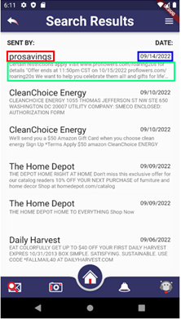

Figure 9 Search Results UI

| **Page: Search Results** | | | | |
| --- | --- | --- | --- | --- |
| **Purpose:** | |  | |  |
| Displays a list view of the of returned mail pieces. Each listing is shown with a sender (red box), date sent (blue box), and digest (green box). Tapping on a mail item will take the user to the individual mail item display. | | | | |
| **What to do:** | |  | |
| Scroll vertically to review mail pieces meeting search criteria. Select a mail piece to go to the mail piece individual page. | | | | |
| **Content:** |  | |  | |
| **1:** | Mail piece list | | Includes each mail piece as a selectable item in a list. Each mail piece includes the Sender, Date Received, and a couple lines of scanned image text. The mail piece image will be displayed on the following page when the mail piece is selected. | |

## Individual Mail piece View

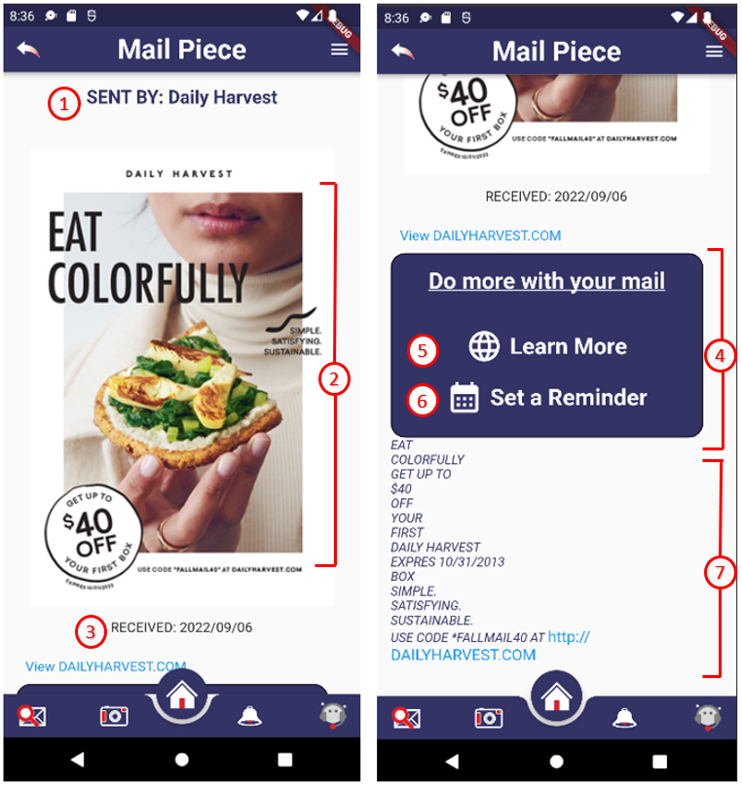

Figure 10 Email Display UI

| **Page: Mail Piece Individual View** | | | | |
| --- | --- | --- | --- | --- |
| **Purpose:** | |  | |  |
| Displays selected mail piece image, sender, received date, relevant links, and image text. Links will open in default web browser when selected. | | | | |
| **What to do:** | |  | |
| The page can be scrolled vertically to view all contents. Links are selectable and will open in the phone default internet browser. | | | | |
| **Content:** |  | |  | |
| **1:** | Sent By: | | Mail piece sender, if known. | |
| **2:** | Mail Piece Image: | | Image from Informed Delivery email, or manually scanned. | |
| **3:** | Received: | | Date when mail piece was received or created manually. | |
| **4:** | “Do more with your mail” | | Area for links associated with informed delivery email mail pieces. Will not display for manually created mail pieces. “Learn More” will not display for certain mail pieces. “Set a Reminder” will not display for links older than 30 days. | |
| **5:** | “Learn More” | | A link sometimes provided with a mail piece by USPS. Generally, a link to a business website. | |
| **6:** | “Set a Reminder” | | Ability to set a reminder via USPS website. The user can select a date to receive a reminder email including the mail piece image and any associated digital content. | |
| **7:** | Text | | Processed text from mail piece image. Embedded links are available as links and have blue color. | |

## Daily Digest

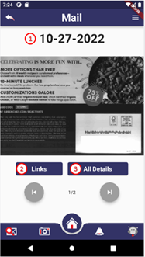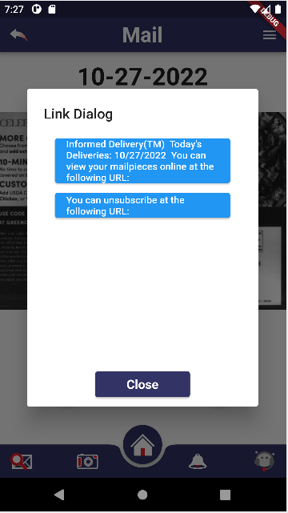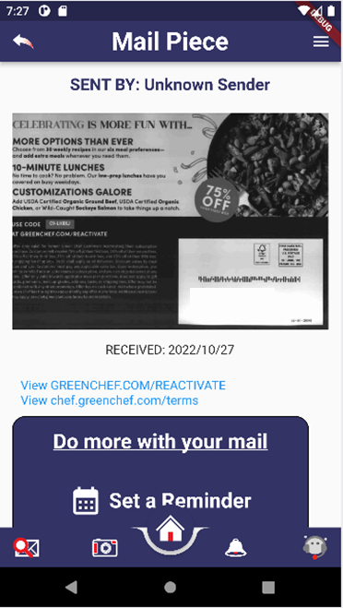

Figure 11 Daily Digest

| **Page: Daily Digest** | | | | |
| --- | --- | --- | --- | --- |
| **Purpose:** | |  | |  |
| This page shows all mail pieces for the latest Daily Digest email that user has received to their email account. | | | | |
| **What to do:** | |  | |
| This page shows all mail pieces for the most recent digest, the user can swipe left or right on the images to see all the Daily Digest mail pieces.  They also can select “All Details” when on a particular image to open the detailed mail piece page.  The links button will open a dialog showing all links in the digest email, selecting them will open the browser. | | | | |
| **Content:** |  | |  | |
| **1:** | Date | | The date the currently displayed Daily Digest mail piece was received. | |
| **2:** | Links | | Opens a dialog which shows clickable links in the Digest or can be closed and return to the Daily Digest view. | |
| **3:** | All Details | | Opens the Mail Piece page for the current mail piece the user is on. | |

## Upload Mail

Figure 12 Upload mail from device

The Upload Mail provides a user with the ability to upload a picture of a piece of mail into the application. When the user selects this feature, the application opens up the devices photos folder to allow a user to select an image. Once a photo is selected, the image is used to import a mail piece. The user is then returned to the main menu.

## Scan Mail

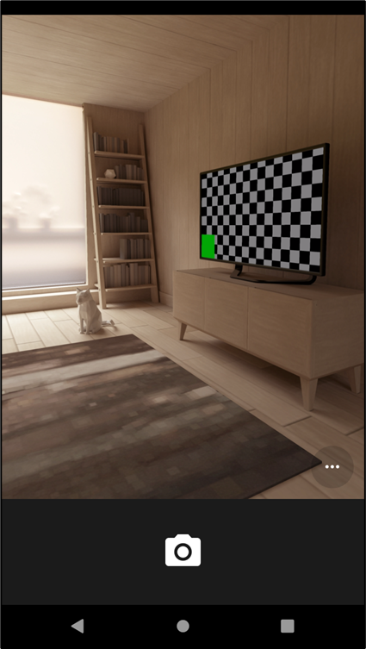

Figure 13 Capture Mail with Camera

The Scan Mail feature allows a user to take a photo of a mail piece and immediately upload it into the application. When a user selects this feature, the application opens up the camera in preparation to take a photo and upload the image into the application. Once a photo is taken, the image is used to import a mail piece. The user is then returned to the main menu.

## Settings

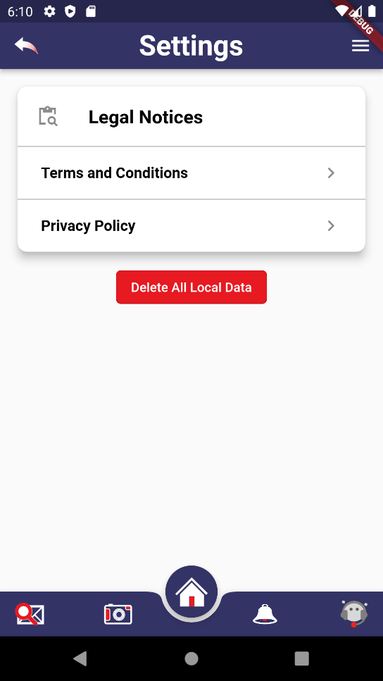

Figure 14 Settings UI

|  |  |
| --- | --- |
| **Page: Settings** | |
| **Purpose:** |  |
| This page allows the user to view all legal notices they accepted by using the app as well as delete all personal data cached by the application. | |
| **What to do:** |
| Click the Terms and Condition button to open a dialog displaying the legal notice. The user can scroll up and down to view the full details of the notice.  Click the Privacy Policy button to open a dialog displaying the legal policy. The user can scroll up and down to view the full details of the apps policy.  Clicking the Delete All Local Data button would open a confirmation dialog asking the user to confirm if they want to delete their cached data. Upon selecting Yes on the dialog, all the users cached data would be deleted from the app, the user would be signed out of the app and redirected back to the login screen. | |
| **Content:** |  |
| Terms and Condition: | Button to open a dialog and display the full Terms and Conditions notice |
| Privacy Policy: | Button to open a dialog and display the full Privacy Policy notice. |
| Delete All Local Data: | Button to delete all the user's personal data from the app. |
|  |  |

## Notifications

### View Notifications

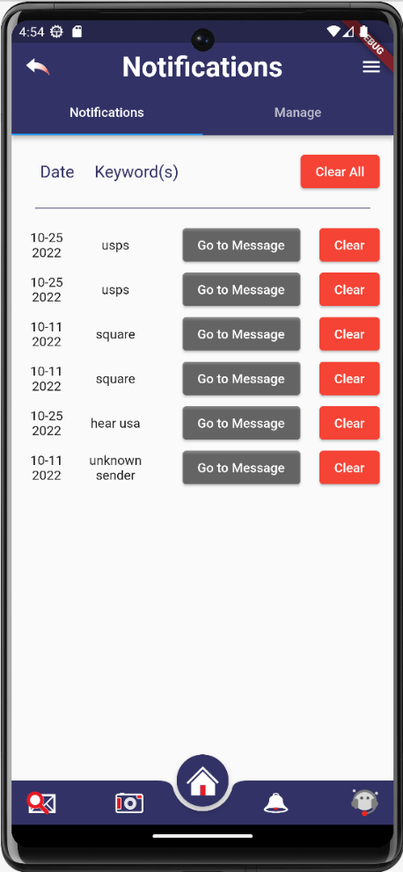

Figure 15 View Notifications Interface

The Notifications View feature enables the user to view notifications for mail pieces by date and keyword. Users can access the specific message by selecting the "Go to Message" button next to each notice. Users can also delete notifications individually by clicking the 'Clear' button next to each notification, or all at once by selecting the 'Clear All' button at the top of the screen.

### Manage Notifications

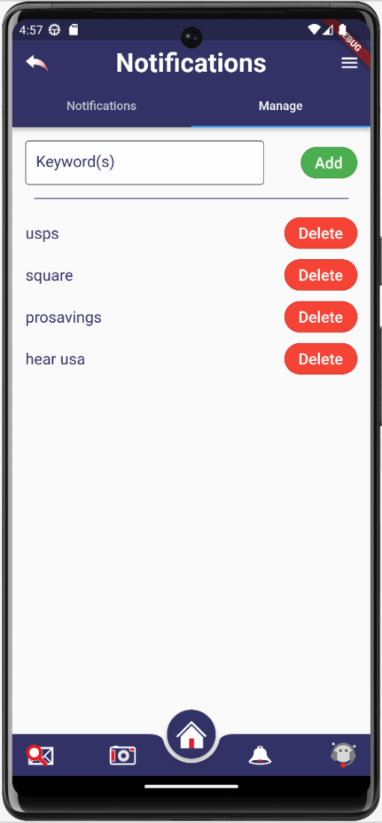

Figure 16 Manage Notifications Interface

The Manage Notifications feature allows users to set their own custom keyword to activate a notification. Users are allowed to add and/or remove keywords as they see fit using this feature.

## Chat Support

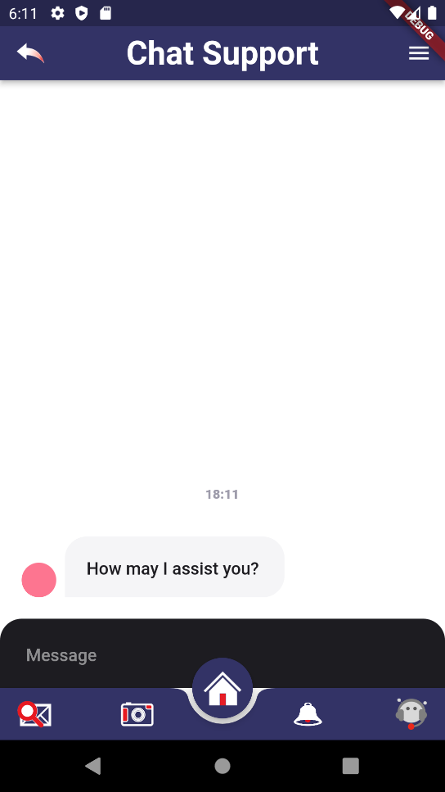

Figure 17 Support Chatbot Interface

|  |  |
| --- | --- |
| **Page: Chat Support** | |
| **Purpose:** |  |
| This page allows the user to interact with a chat bot for assistance in the application. | |
| **What to do:** |
| This page will answer questions the user has pertaining about the app. Such as, “where is my mail” or “how to see my daily digest”. The chat bot will reply in a text format which the user can read and reply to if there are further questions. | |
| **Content:** |  |
| Message | This is where the user can enter their question |
| Text Bubbles | This is where the conversation will be recorded from both parties. The right side of bubbles will be the users and the left are the chatbot. |
|  |  |

# Launching the Application

## Permissions

In the Step-by-Step guide, there are a few steps that will require users to review permissions for the app on their devices. Some features of MailSpeak will need access to the media (photos), camera, and other functionality on a user’s device. When prompted, either choose **allow only while using the app is in use** or **ask every time**.

# Step-by-step Guide

|  |  |  |
| --- | --- | --- |
| Mail speak icon | | * User taps the icon to launch the application. |
|  | **Email Login**   * The application email login screen loads. * User enters their email address * User enters their email password   Or   * User selects to sign in google * User selects that they have read terms/privacy policy * User clicks Retrieve Mail, application uses email address and password to retrieve email using IMAP protocol from mail server matching informed delivery criteria. * Users have the option to launch URL to register for Informed Delivery. | |
|  | **Main Menu**   * The main menu is the primary navigation menu with little functionality * From here, the user may select which action they would like to take next * Selecting any button will take the user to the corresponding screen | |
|  | **Mail Search – Standard**   * This page allows the user to select a date range and keyword to search their mailbox for. * The highlighted “<” and “>” at the top of the calendar can be used to navigate months. * The user can click on dates on the calendar to automatically set start and end dates. * If a mis-click occurred when selecting dates, the user only needs to click the same date again to remove the selection. * Keywords can be typed into the textbox at the bottom. This will search for mail senders or mail content that match. * Users can also fine tune their mail search by clicking the "Advanced Search” button at the bottom. | |
|  | **Mail Search – Advanced**   * The advanced search allows users to fine tune their keyword search by allowing them to specify sender or content search. * Users can choose to specify a sender and/or content search independently, rather than the standard search for the keyword in both. * Finally, the user selects the “Search” button to be presented with their search results | |
|  | **Search Results**   * Here, the user is presented with the search results based on the parameters they input in the Mail Search screen * Each mail piece is represented by the sender, a preview of the contents, and the date it was received. * Users can scroll through the list to browse all of the results. * When users wish to see a mail piece in greater detail, they just need to click on it. | |
|  | **Mail Piece**   * This is the detailed Mail Piece page * At the top of the page, users can see the sender, a scan of the mail piece, the date it was received, and links to any URL’s that were located on the mail piece. * Users can click on the links to navigate to those URL’s | |
|  | **Mail Piece – Cont.**   * In the second half of the detailed Mail Piece view, users see the “Do more with your mail section” and a transcription of the mail piece. * Selecting “Set a Reminder” will navigate the user to informeddelivery.usps.com where they can choose a date to receive an email reminder for the selected mail piece. * Clicking on links within the transcript will take you to the website using your devices default internet browser. | |
|  | **Daily Digest – Access Request**   * When opening the MailSpeak app for the first time and selecting “Daily Digest”, the user may be presented by a request for access popup. * Select “Allow” so the application may operate efficiently. | |
|  | **Daily Digest**   * This page presents the user with a breakdown of their daily digest for the day. * Clicking “Links” will open the Link Dialog. * Clicking “All Details” will take the user to the detailed Mail Piece page. * The user may navigate between the individual pieces in the daily digest using the arrow buttons at the bottom. | |
|  | **Daily Digest – Links**   * The links for the specific mail piece are displayed on this dialog. This way the user can interact with their most recent mail pieces without having to open the detailed Mail Piece page. * Selecting either button will take the user to the corresponding URL via their internet browser. * Clicking “Close” will reveal the underlying Daily Dialog page. | |
|  | **Daily Digest – Mail Piece**   * The detailed Mail Piece page is shown if “All Details” was selected in the Daily Digest page. | |
|  | **Settings**   * This page can be reached by selecting “Settings” from the main menu. * The buttons in the Legal Notices section open the corresponding notice. * Selecting “Delete All Local Data” will clear the local memory cache, forcing the application to redownload and reprocess all of the user’s mail. | |
|  | **Settings – Terms and Conditions**   * The user can scroll through the Terms and Conditions of the application. * Click “Close” to reveal the underlying settings page. | |
|  | **Settings – Privacy Policy**   * The user can scroll through and read the Privacy Policy of the application. * Click “Close” to reveal the underlying settings page. | |
|  | **Notifications – Notifications**   * This page can be reached by selecting “Notifications” from the main menu. * On this page, the user can view all of their current notifications and the keywords that triggered the notification. * Clicking “Clear All” will delete all of the notifications. * Selecting “Go to Messages”, the user will be directed to the message which triggered the notification subscription. * The user can also clear that single notification by clicking the “clear” button on that line. * Selecting the “Manage” tab toward the top of the page will navigate the user to the notifications management page. | |
|  | **Notifications – Manage**   * In the notifications management tab, the user can manage keywords that trigger notifications. * Entering a word into the textbox at the top and selecting “Add” will add a new keyword. * Once keywords are added they will be displayed in a list below the textbox. * The user may select “Delete” to remove any of the listed keywords and prevent them from triggering future notifications. | |
|  | **Scan Mail**   * This dialog can be reached by selecting “Scan Mail” in the main menu. * To use the scan mail function, the user must select one of the first two options. This permission allows the application to use the phone’s camera to scan the mail. | |
|  | **Chat Support**   * Chat support can be accessed via the icon at the bottom right (to the right of the notifications bell). * The user may type into the text box at the bottom of the screen. * Entering “help” will show the user all possible commands. * Users can get detailed instructions for each command by entering “<command name> help”. For example entering “digest help” returns “digest: Navigates to Daily Digest page”. * This feature when paired with native speech-to-text can help the visually impaired navigate and operate this application. | |

# 

# FAQ / Troubleshooting

This section is here to provide quick troubleshooting steps for issues that may occur while using the app that can be supported quickly by the end-user.

## Application is not updating

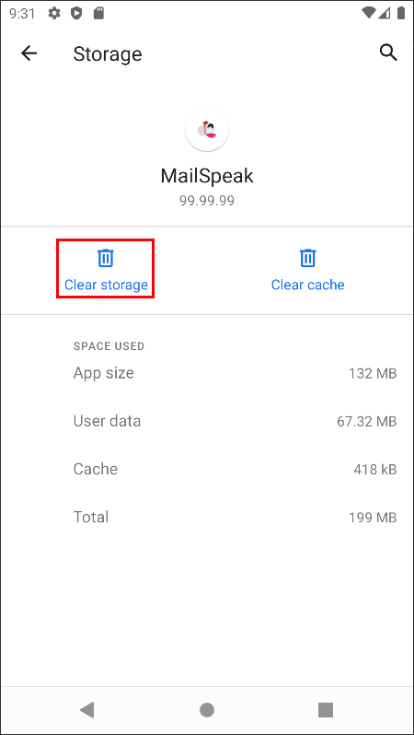**Clear the applications storage by following these instructions.**

* Graphical user interface, application

  Description automatically generated Locate the app icon
* Long press to get the context menu
* Select App info
* From App Info, choose Storage and cache as shown to the right.
* Click on Clear Storage shown in the image on the right

## Application can’t log in to email account

|  |  |
| --- | --- |
| If entering your username and password does not work, your email provider may require you to create a special “app password” to log in with instead. To do this, utilize the link below for instructions for your provider, or search for “[my email provider] create app password” to create it. Once created, you should be able to log in to MailSpeak with that new password.   * AOL: <https://help.aol.com/articles/Create-and-manage-app-password> * Yahoo: <https://help.yahoo.com/kb/SLN15241.html> * Gmail: <https://support.google.com/accounts/answer/185833?hl=en> * Outlook: <https://support.microsoft.com/en-us/account-billing/using-app-passwords-with-apps-that-don-t-support-two-step-verification-5896ed9b-4263-e681-128a-a6f2979a7944> |  |

## Application is not loading new email

|  |  |
| --- | --- |
| If the application is looked like it is logged in, click on settings.   * Tap the Delete All Local Data * Close the App * Open the App back up * Log back in with your Informed Delivery registered email address. |  |

## Unable to upload mail image or use camera

|  |  |
| --- | --- |
|    * Locate the app icon * Long press to get the context menu * Select App info * Select Permissions * Tap on Files and Media   + Make sure Allow access to Media only is selected * Tap on Camera   + Make sure either Ask every time or Allow only while using the app is selected |  |